NEWS

Happy New Year!

Welcome back. Hope you’ve had a great Christmas holiday.

It’s been great to get out and visit lots of you and see what you are doing in your schools. There are some great noticeboards and the competitions are going well. There will be a new competition idea to do this term with this newsletter. Don’t forget to keep a record of your activities in a folder or diary. There are prizes for the best school in the summer.
If I didn’t get to visit you last term then please get in touch to arrange a meeting. I can help you to plan your JRSO activities for the rest of the year. Also, it’s not too late to get started. If you need some help just let me know.

There are lots of exciting things going on in 2017. The Tour de Yorkshire will be back in North Yorkshire in April. Stage 1 finishes in Scarborough on April 28th then Stage 2 starts in Tadcaster on Saturday April 29th April and finishes in Harrogate. What will your school be doing to celebrate cycling this year? The Bikeability cycle training courses for Year5 and 6 will continue to run throughout the spring and summer. Have you booked your places?
Resources
The JRSOs will be supported in their work by the Road Safety & Travel Awareness team. Information and resources will be regularly updated on the Road wise website www.roadwise.co.uk

The JRSOs will receive a handbook, badge and other resources when your school is registered for the 2016/17 scheme.

Please get in touch if you need anything for your JRSO scheme.

Ann Smallwood Road Safety and Travel Awareness Officer
Ann.smallwood@northyorks.gov.uk

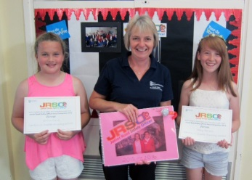
Do you know the Green Cross Code?

So, can you rearrange the five steps below into the correct order?
LOOK AND LISTEN
STOP
THINK

WALK, DON’T RUN
WAIT TILL IT’S SAFE

QUIZ Time

- What material will make you more visible during the day?
- Dark Colours
- Bright, fluorescent colours
- Pale colours
- Reflective

- When cycling what should you always do before signalling?
- Look behind
- Check your balance
- Ring your bell
- Nothing

- Which of the following ages groups are most likely to be killed or injured as pedestrians in road accidents?
- 3-6 year olds
- 7-10 year olds
- 11-14 year olds
- 15-18 year olds

WALK SAFE

Listen for traffic!
Pay attention!
Cross Safely!
Give the road your full attention. Hide your phone in a bag or a pocket.
Be seen!
Look after your friends!

