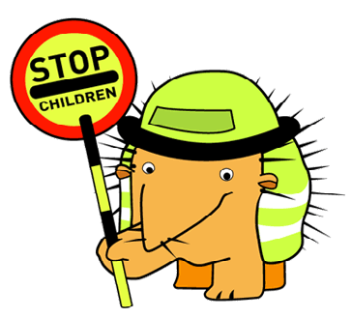

Hello again JRSOs!

We hope you are all having fun in your role as JRSOs and 2018 has started with you being safe and encouraging your fellow pupils to do the same.

We are looking forward to hearing about all the original and interesting ways you are promoting road safety within your schools, why not hold an assembly or organise a walk to school day to get everyone involved.

North Yorkshire Road Safety are very proud to support such an important scheme because safety here is a number one priority.

Keep up the good work JRSOs

Rachael Hudson - Drax, External Affairs Officer

**Junior Road Safety Officer Scheme**

**February 2012Newsletter**

* Don’t forget to fill in your JRSO diaries to let us know what you’ve been doing
* Remember to update your JRSO notice board, you could put up details of the competitions and display the winning entries
* If you need anything to help you in the role of JRSO or prizes for your competition winners please get in touch: caron.twamley@northyorks.gov.uk

**Quick Walking Quiz…..**

Walking to school is fun! It gives you a chance to meet up with your friends, spend time with your family and get some exercise. You can walk whatever the weather –enjoy the sunshine or splash in puddles when it rains – and don’t forget to wrap up warm in the winter. In bad weather, there is even more congestion on the roads, so it is often quicker to leave the car at home and go on foot.

1. **How much exercise should children take each day?**
   1. 2 hours
   2. 1 hour
   3. 30 minutes
2. **How many steps should you walk each day?**
   1. 12,000
   2. 15,000
   3. 10,000
3. **How many children in the UK walk to school?**
   1. 97%
   2. 22%
   3. 41%

How well do you know the Green Cross Code?

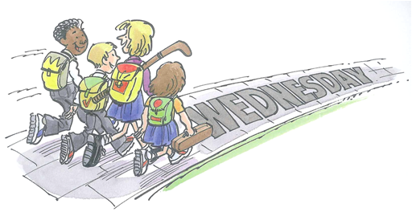

* First find a **s_ f _ r** place to cross, then **s _ _ _**
* **C** _ _ _ **s** when there is no traffic and there is enough **_ _ _ e** to get to the other side without running. If you are unsure don’t cross
* **S** _ _ _ **d** on the pavement, but not too close to the edge of the kerb
* Keep **l** _ _ _ _ _ **g** and_ _ _ _ _ _ **ing**for traffic as you cross the road
* _ _ _ **k** straight across the road. Do not run
* **L** _ _ _ and **l** _ _ **t** _ **n** in all directions for any traffic and **t _ _ n _** about what you are doing

**JRSO top tips from**

**Caron Twamley**

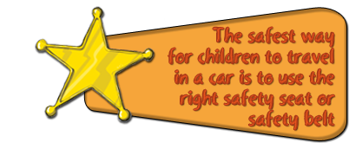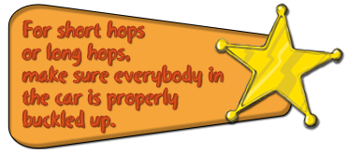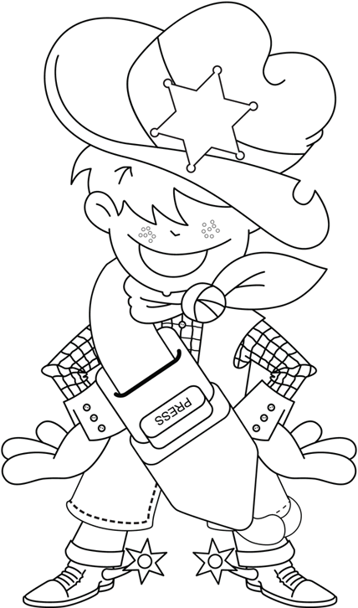

Some Ideas for competitions could be:

* Design a seatbelt cover that is fun and funky but reminds you to buckle up (A4 length x 5cm)
* Make a height chart to show the school exactly how tall you need to be (135cm) before you can use a seatbelt only
* Colour in Seatbelt Sheriff (right)

**Or check www.roadwise@northyorks.gov.uk**

for more ideas!

Here is the Spring Term Competition for Key Stage 1 and 2 for you to have a go at.

It’s your job as JRSOs to tell everyone about the competition, inform them of the closing date, collect the entries and judge the best ones, or ask your teacher to help judge them. Don’t forget to tell everyone to put their name and class on their entry!

Seatbelt Sheriff says

“B**uckle Up Partner**”