Be Safe on the way to school
Year 6
As you get older you’ll feel more confident being out and about-and you may start to travel all or part of the way to school without a grown up. You may travel on your own or with friends. Make sure that you have thought about what you can do to keep safe.

Before you set off, plan your route. That way you won’t be late for school.
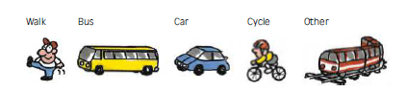

- How long will the journey take you?

- At what time will you have to leave the house in the morning?

- Who will you travel to school with?

- List the things you will need for school each day?

- What do you need to do to keep yourself safe on the school journey?

Describe or draw a sketch map of your journey to school.

