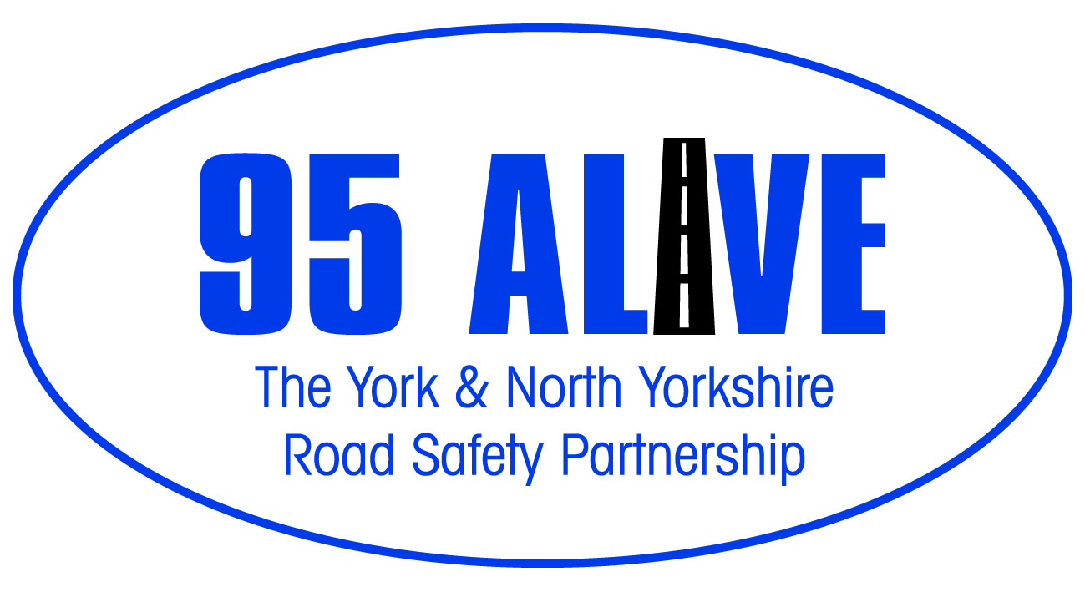

British summertime ends on the 26th October, the clocks go back by an hour and most of us may be travelling home in the dark.

However you get to work or school, there are things you can do to help yourself be seen, making sure other road users can see you.

Pedestrians

Whether walking to and from school, the shops, or walking the dog, during foggy and overcast days pedestrians should wear something bright coloured and something reflective at night. Choose a bag or rucksack with hi visibility strips. Fluorescent and reflective armbands can be worn over coats and clothing, and stickers can be used on bags. Reflective dots on knees and ankles can really draw attention to runners during dark nights.
Keep to the footpath where there is one, if not, keep to the right hand side of the road so you can see oncoming traffic. Being aware of your surroundings can help aswell, so take out the earphones, and leave your phone in your pocket.

Cyclists

Many people riding bikes at night assume that street lights are enough for a motorist to see them, as they can see themselves. This is not the case and many incidents involving bicycles during the dark nights are due to cyclists in dark clothing with no lights or reflectors. Drivers are looking for lights, so when a cyclist appears with no lights, it comes as a surprise.

At night, your bike MUST have white front and red rear lights lit, it must also be fitted with a red rear reflector. White front reflectors can also help you to be seen, and spoke reflectors will help other road users see you from the side.

Other things like reflective tape and flashing valve caps are also available. Any part that is moving, such as knees and ankles and valves, and is either reflective or illuminated, draws drivers attention to you quite well.
Wear bright and if possible reflective clothing and still always believe that the driver has not seen you.

In the car

Regularly check that all of the lights are working and use them. Most of us have seen vehicles with only one headlight working looking from a distance like a motorcycle and in some cases just one dim sidelight. If you can’t be seen you are in danger of being involved in a crash and if any of your lights are not working you are breaking the law.
Consider if you are using other lights that could dazzle road users and stop them from seeing other hazards. Do not use front or rear fog lights unless the visibility is seriously reduced. The Highway Code says, “Generally less than 100 metres (328 feet).”

Try to keep the car clean so that it reflects light and makes it easier to see. Pay particular attention to lights, windows and mirrors as the slightest bit of dirt or mist can defuse light and make it hard to see. Don’t forget that cleaning the inside of the window is as important as the outside.
Carry a hi-visibility vest or jacket and put this on if you should need to get out of the car in the dark. (This is already a legal requirement in some European countries.)
Be very aware that other road users may not be doing anything to keep themselves visible. Better use of lights will help you to see and avoid others.

Vans

If you drive a van all of the points made for cars will apply but also remember that when you are loading or unloading you could be particularly vulnerable.
Try to park in safe place where there is good lighting and less traffic flow. If this is not possible, keep the side and tail lights switched on to attract attention and use good quality hi-visibility clothing.
Wherever possible try use side loading doors at the curb side. You would not want to be standing at the rear of the van if someone runs into it.
Pay particular attention when walking out into the road. Bright lights behind you will make your hi-visibility clothing ineffective.

Motorcycles

If you ride a motorcycle you probably already know that you are apparently invisible to some other drivers even in good daylight. For this reason many motorcyclist always drive with their dipped headlight on. However some studies have shown that in certain circumstances that can make it more difficult for other drivers to assess the speed of the approaching bike.
This situation is further compounded when it is dark. Riding in a more dominant road position, (out from the curb and more to the middle of the lane), will help others to see you and give you a better view into side roads and round trees and lamp posts. This will give you and others more time to react if a problem does occur.
As with other vehicles, a bright shiny bike and bright and helmet will improve your chances of being seen. Light or hi-visibility clothing may also help drivers behind to see you.
Do not use a tinted visor at night as it will make it difficult to see pedestrians and cyclist in dark clothing.
No matter how bright and visible you have made yourself, always ride believing that the other road user has not seen you.

