
Safer parking at the school gates.

Driving children to school is seen as the most convenient choice for parents with busy lives. Many parents take the view that by driving their children to school they are keeping them safe. Yet the combination of each individual decision means an increase in vehicle traffic and congestion particularly at the school gate.

Many children now miss out on the opportunity to develop vital road safety skills with their parents on the way to school. They fail to build up confidence and learn the ability to manage risk walking around their local community.

Walking can improve overall fitness levels in children and adults. It is a cheap low impact way to exercise. Getting active in our daily lives can have a big impact on health issues such as obesity.

We realise that there are some parents/carers who have no alternative but to drive their children to school, however, many are driving short distances where walking is a real option.
Even those who have to drive to school can do their bit by parking away from the school entrance and walking for part of the journey.

What can you do to help keep everyone safe around the school gates?
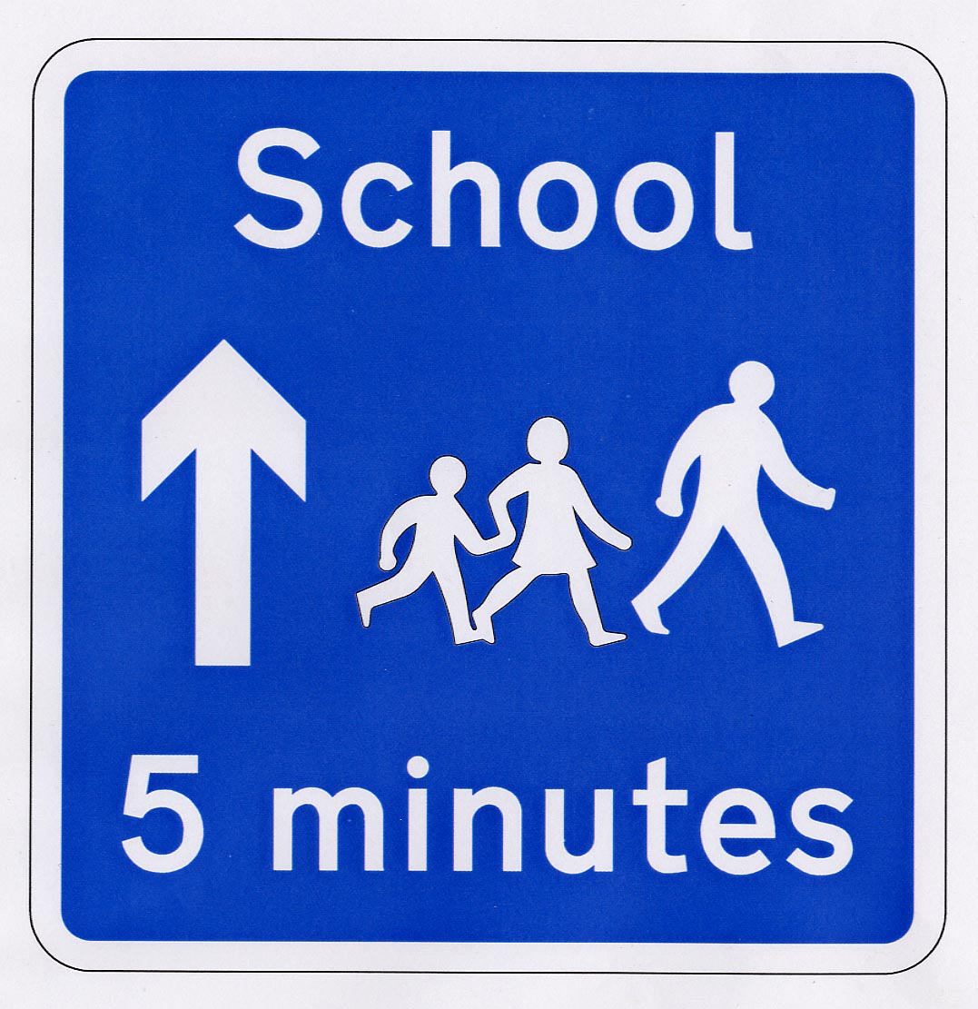
Please don’t:
- Block the road - emergency vehicles and other traffic may need access
- Park on yellow lines, zig-zags or block the school entrance

- Park on the pavement, across dropped kerbs or residents’ driveways
- Park opposite or within 10 metres of a junction
- Park where you will cause inconvenience to other road users
- Leave your vehicle with the engine still running
- Stop in the middle of the road to drop your child off, even for a few seconds.

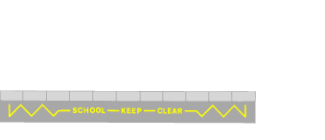
These changes make a real difference to the congestion around schools, making the school run less stressful and far safer for everyone. Not only that but they will help your child’s education. Research has shown that children who walk or cycle to school are more receptive to learning at the start of the school day than those who travel to school by car.

