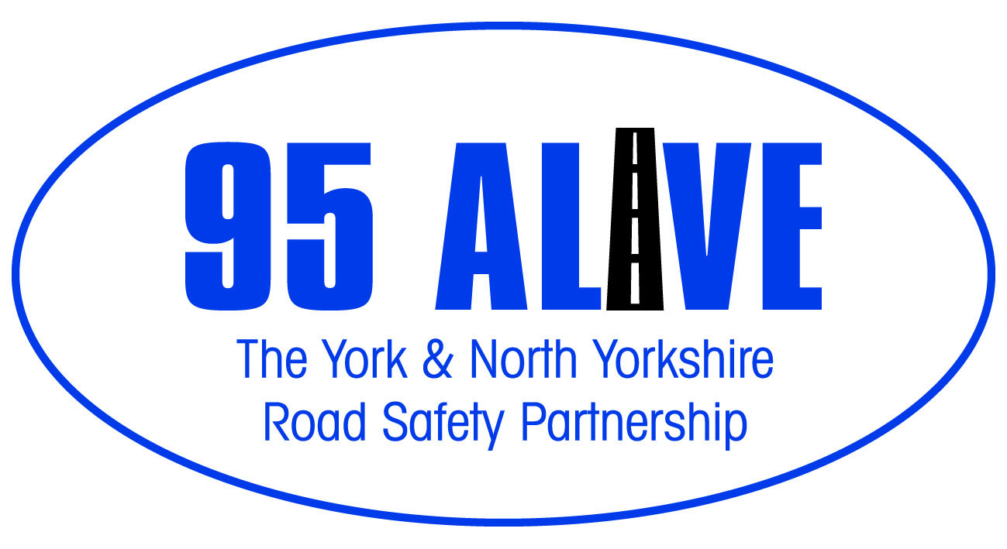

Office use only

Speed Concern Report

Please note – ALL details are required.

Name (Dr / Mr / Mrs / Ms / Miss)
Address:
Postcode:
Tel Number (s):
E mail:
Vehicles exceeding speed limit along: (Road name):
at/ near to: (house number / junction with)
MON / TUE / WED / THUR / FRI / SAT / SUN / ALL DAYS
Time(s):
(if all day is there any time that you feel is worse)?
Type of vehicle:
(Car / Motorcycle / Lorry / Bus / All Vehicles)
Driven by: | Local Residents / General Traffic / Employees of;- (delete as appropriate)
1.
2.
3.

Additional Information:

Signature

I would be willing to participate in any Community Action initiatives regarding the issue I have raised. | YES / NO

This form should be returned to –
North Yorkshire Police Traffic Bureau, PO Box 809, York, YO31 6DG
email: speedconcerns@northyorkshire.pnn.police.uk

You will receive an acknowledgement

