95 ALIVE
YORK AND NORTH YORKSHIRE
ROAD SAFETY PARTNERSHIP

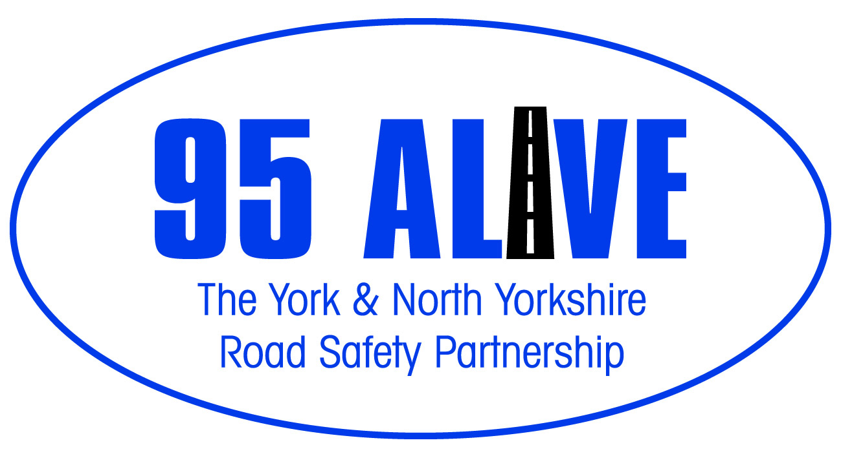

GRANT APPLICATION FORM
FOR CASUALTY REDUCTION PROJECTS/INITIATIVES up to £2,499.99

Please complete the attached form and return it by email to:

95alive@northyorks.gov.uk

Please refer to the 95 Alive Grant Fund Guidance Notes before completing this application form.
The maximum award you can apply for is £2,499.99. Your completed application should not exceed five typed pages; appendices will not be considered.
Please note, if your application is successful we will publicise how the money is being put to good use and raise awareness of the excellent work being supported by 95 Alive.
Applicant Details:

Name of individual applicant / community group/ organisation

- Purpose of group / organisation – max 50 words.

- Name of Project

- Project location (Countywide or area?)

- Please write a short statement (max 300 words) on how your project supports the identified aims within the 95 Alive Strategy.

- Please provide an overview of your project, what you aim to do (outputs & objectives), how you will know if you project has been successful. (max 500 words)

- Are there plans to continue the project once the grant fund is spent? (max 200 words)

Total Cost of Project: ______

Amount of Grant applied for (Max £2,499.99)Total: ______

Additional Sources of Funding/Resources ______

APPROVAL PROCESS

Application received by ______________ Date ________ Signed ___________

Working Group Meeting _____________ Date _________ Signed___________

OWG Approved / Rejected ___________ Date _________ Signed ___________

Name of Organisation: ____________________________________

Contact Name: ____________________________________

Telephone Number: ____________________________________

E-Mail Address: ____________________________________

Address:
__________________________________________________________________________________________________________________________________________________________________________________________
Post Code: ___________

Do you have a Bank Account? YES/NO

Do you have a constitution/set of rules? YES/NO

