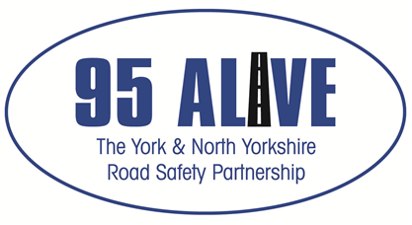

95 Alive – York & North Yorkshire Road Safety Partnership Grant Application Guidance Notes.

The 95 Alive York and North Yorkshire Road Safety Partnership have been mandated by the Office of the Police and Crime Commissioner (OPCC) to manage the submission of funding requests in support of projects that address local collision, casualty and road safety issues and have a substantial impact on the priorities identified in the 95 Alive Road Safety Strategy document. The funding will be provided from North Yorkshire Police (NYP) on behalf of the OPCC and will be managed by the 95 Alive Partnerships, Officer Working Group (OWG). The max award that can be applied for is £2,499.99.

OPCC / 95Alive Road Safety Partnership

Funding Application Terms & Conditions

- All organisations must be an identifiable body, with appropriate bank account. Projects must be committed to providing equality of opportunity.

- All projects must directly support the priorities within the 95 Alive Strategy document. Grant applications from bodies external to the 95 Alive partnership will not be considered, if they fall within the remit of an already set-up and established process (ie funding of speed guns to parish councils, when we have the Community Speed Watch and Speed Management Protocol)

- Or where an Authority holds a statutory duty to provide. (such as changes in speed limits or creation of 20 limits or addition of signage, including VAS)

- The project must be based within the York or/and North Yorkshire area.

- Funding will be spent only on authorised items or projects as described in the application and comply with the Grant Project Agreement Form.

- All capital assets purchased as part of this programme must be inventoried, adequately stored, maintained, insured and available for inspection upon request.

- Any capital asset costing more than £1000 purchased by grant must not be sold or otherwise disposed of within 5 years of purchase without prior consent of the 95 Alive Officer Working Group (OWG) and will be monitored for a maximum period of five years.

- Successful applicants will be required to provide a half yearly update and end of project performance & finance reports as agreed in the Grant Project Agreement. All payments will be subject to timely delivery of reports.

Failure to comply may result in the funding being withdrawn/recharged and the recipient organisation barred from further funding for a fixed period.

- Bodies or Organisations, based within York & North Yorkshire, who are not part of the 95 Alive Lead may apply for this funding by applying via Grant Application Process. All these projects will be branded as 95 Alive, with the original source of funding (OPCC) identified as an addition.

- Alternative funding for projects maybe identified by a number of Lead Partners inputting an amount of funding each to a project, for work across a localised area (either County, Unitary, across both or via a Yorkshire & Humber Regional project). In this case an agreed Lead and the project will be run in accordance to those Authorities financial procedures. Again, with the agreement of OWG these projects may be branded as 95.

- All applicants must return any unspent funds to NYP via 95 Alive

- Any applicant found to be in default of the Terms and Conditions will be liable to repay the total grant.

- The Contact Name, provided on the application will be responsible for providing the half yearly and final reports on this project, which should include any information on how you have measured your success and what you have achieved in outcomes as outlined in the Grant Project Agreement.

- If your application is successful we will publicise how the money is being put to good use and raise awareness of the excellent work being supported by 95 Alive.

