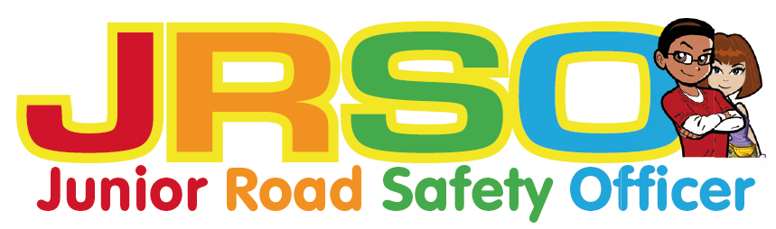
Junior Road Safety Officer Competition
Spring 2018

Be Safe on the way to school

How do you usually travel to school?

Choose one of the following sheets to decorate and label with top tips for keeping safe.

- In a car
- On wheels
- On foot

Closing Date:_____________________

Don’t forget to put your name and class on your entry.

There is a special sheet for Year 6 pupils to do too.

