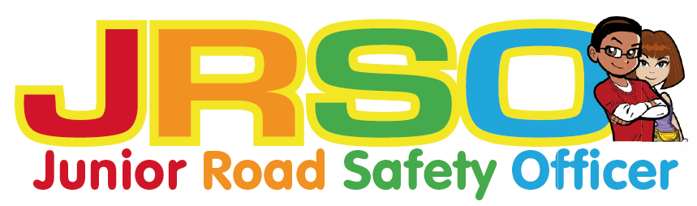

Junior Road Safety Officer Calendar
A timetable of activities is provided to help you plan the activities with suggested themes and topics. However, the JRSOs should be encouraged to come up with their own ideas

Month | Tasks
September | Organise a meeting with new JRSOs.  Start to plan ahead.  Decide where you can have a notice board and introduce the JRSOs at assembly.  Start a file/ diary to record your activities.
October | Themes: Be bright Be Seen and Walk to School Month  Organise this term’s competition for Key Stage 1 and 2
November | Theme: Green Cross Code
December | Make sure the JRSO file/diary is up to date. Include photos and pictures.
January | Make sure the notice board is up to date
February | Themes: Seatbelts and Car Seats  Organise this term’s competition
March | Theme: School Gate Parking
April | Make sure the JRSO file/diary is up to date. Include photos and pictures.
May | Theme: Safer Cycling  Organise summer competition
June | Finishing Off: Make sure the JRSO file is up to date
July | Final meeting with the JRSOs. Thank them for all their hard work during the year.  Advertise for next year’s JRSOs.
August | Holiday


More help and information
Caron Twamley Road Safety and Travel Awareness Officer
caron.twamley@northyorks.gov.uk
07792 985508

