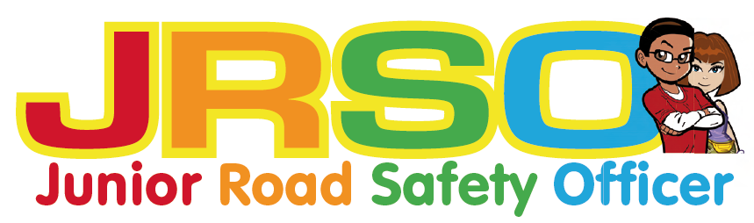

Junior Road Safety Officers: A guide for schools 2019-20

Introduction
Junior Road Safety Officers (JRSO’s) are nominated Year 5 pupils in primary schools who relay key Road Safety messages to the whole school community. The pupils take part in fun learning activities which they can share with others.

During their time in office, JRSO’s are supported by the school and North Yorkshire County Council Road Safety and Travel Awareness Team. There are many ways that the pupils can get involved, including:
• School assemblies
• Notice boards
• Competitions

The JRSOs are encouraged to keep a diary, folder or video evidence of their activities throughout the year.

Aims:
• To reduce the numbers of children injured on the roads
• To promote a sense of responsibility and positive citizenship among children
• To enhance the importance of safety among pupils, parents and school staff
• To develop innovative ways of putting safety messages across
About the Scheme
At the start of each academic year every Primary school is encouraged to appoint 2 JRSOs from Year 5.
- At present the main method of communication with the schools and JRSOs is via email.
Information can also be found on the Roadwise website. www.roadwise.co.uk
- The scheme runs best in the schools where the JRSOs have an enthusiastic helper in school (a teacher, TA or parent)
- When the JRSOs have been appointed they will receive information from NYCC.
- The JRSOs will be given themes on which to base their work each term.
- The JRSOs have key areas of activity to develop. These may include putting up and maintaining a prominent notice board, running school competitions, giving class or assembly presentations.

Role of NYCC
- To provide information about the JRSO scheme to schools via email and the Roadwise website
- To keep records of schools involved in the scheme
- To inform schools of the termly competitions

Caron Twamley, Road Safety and Travel Awareness Officer
caron.twamley@northyorks.gov.uk 07792 985508

