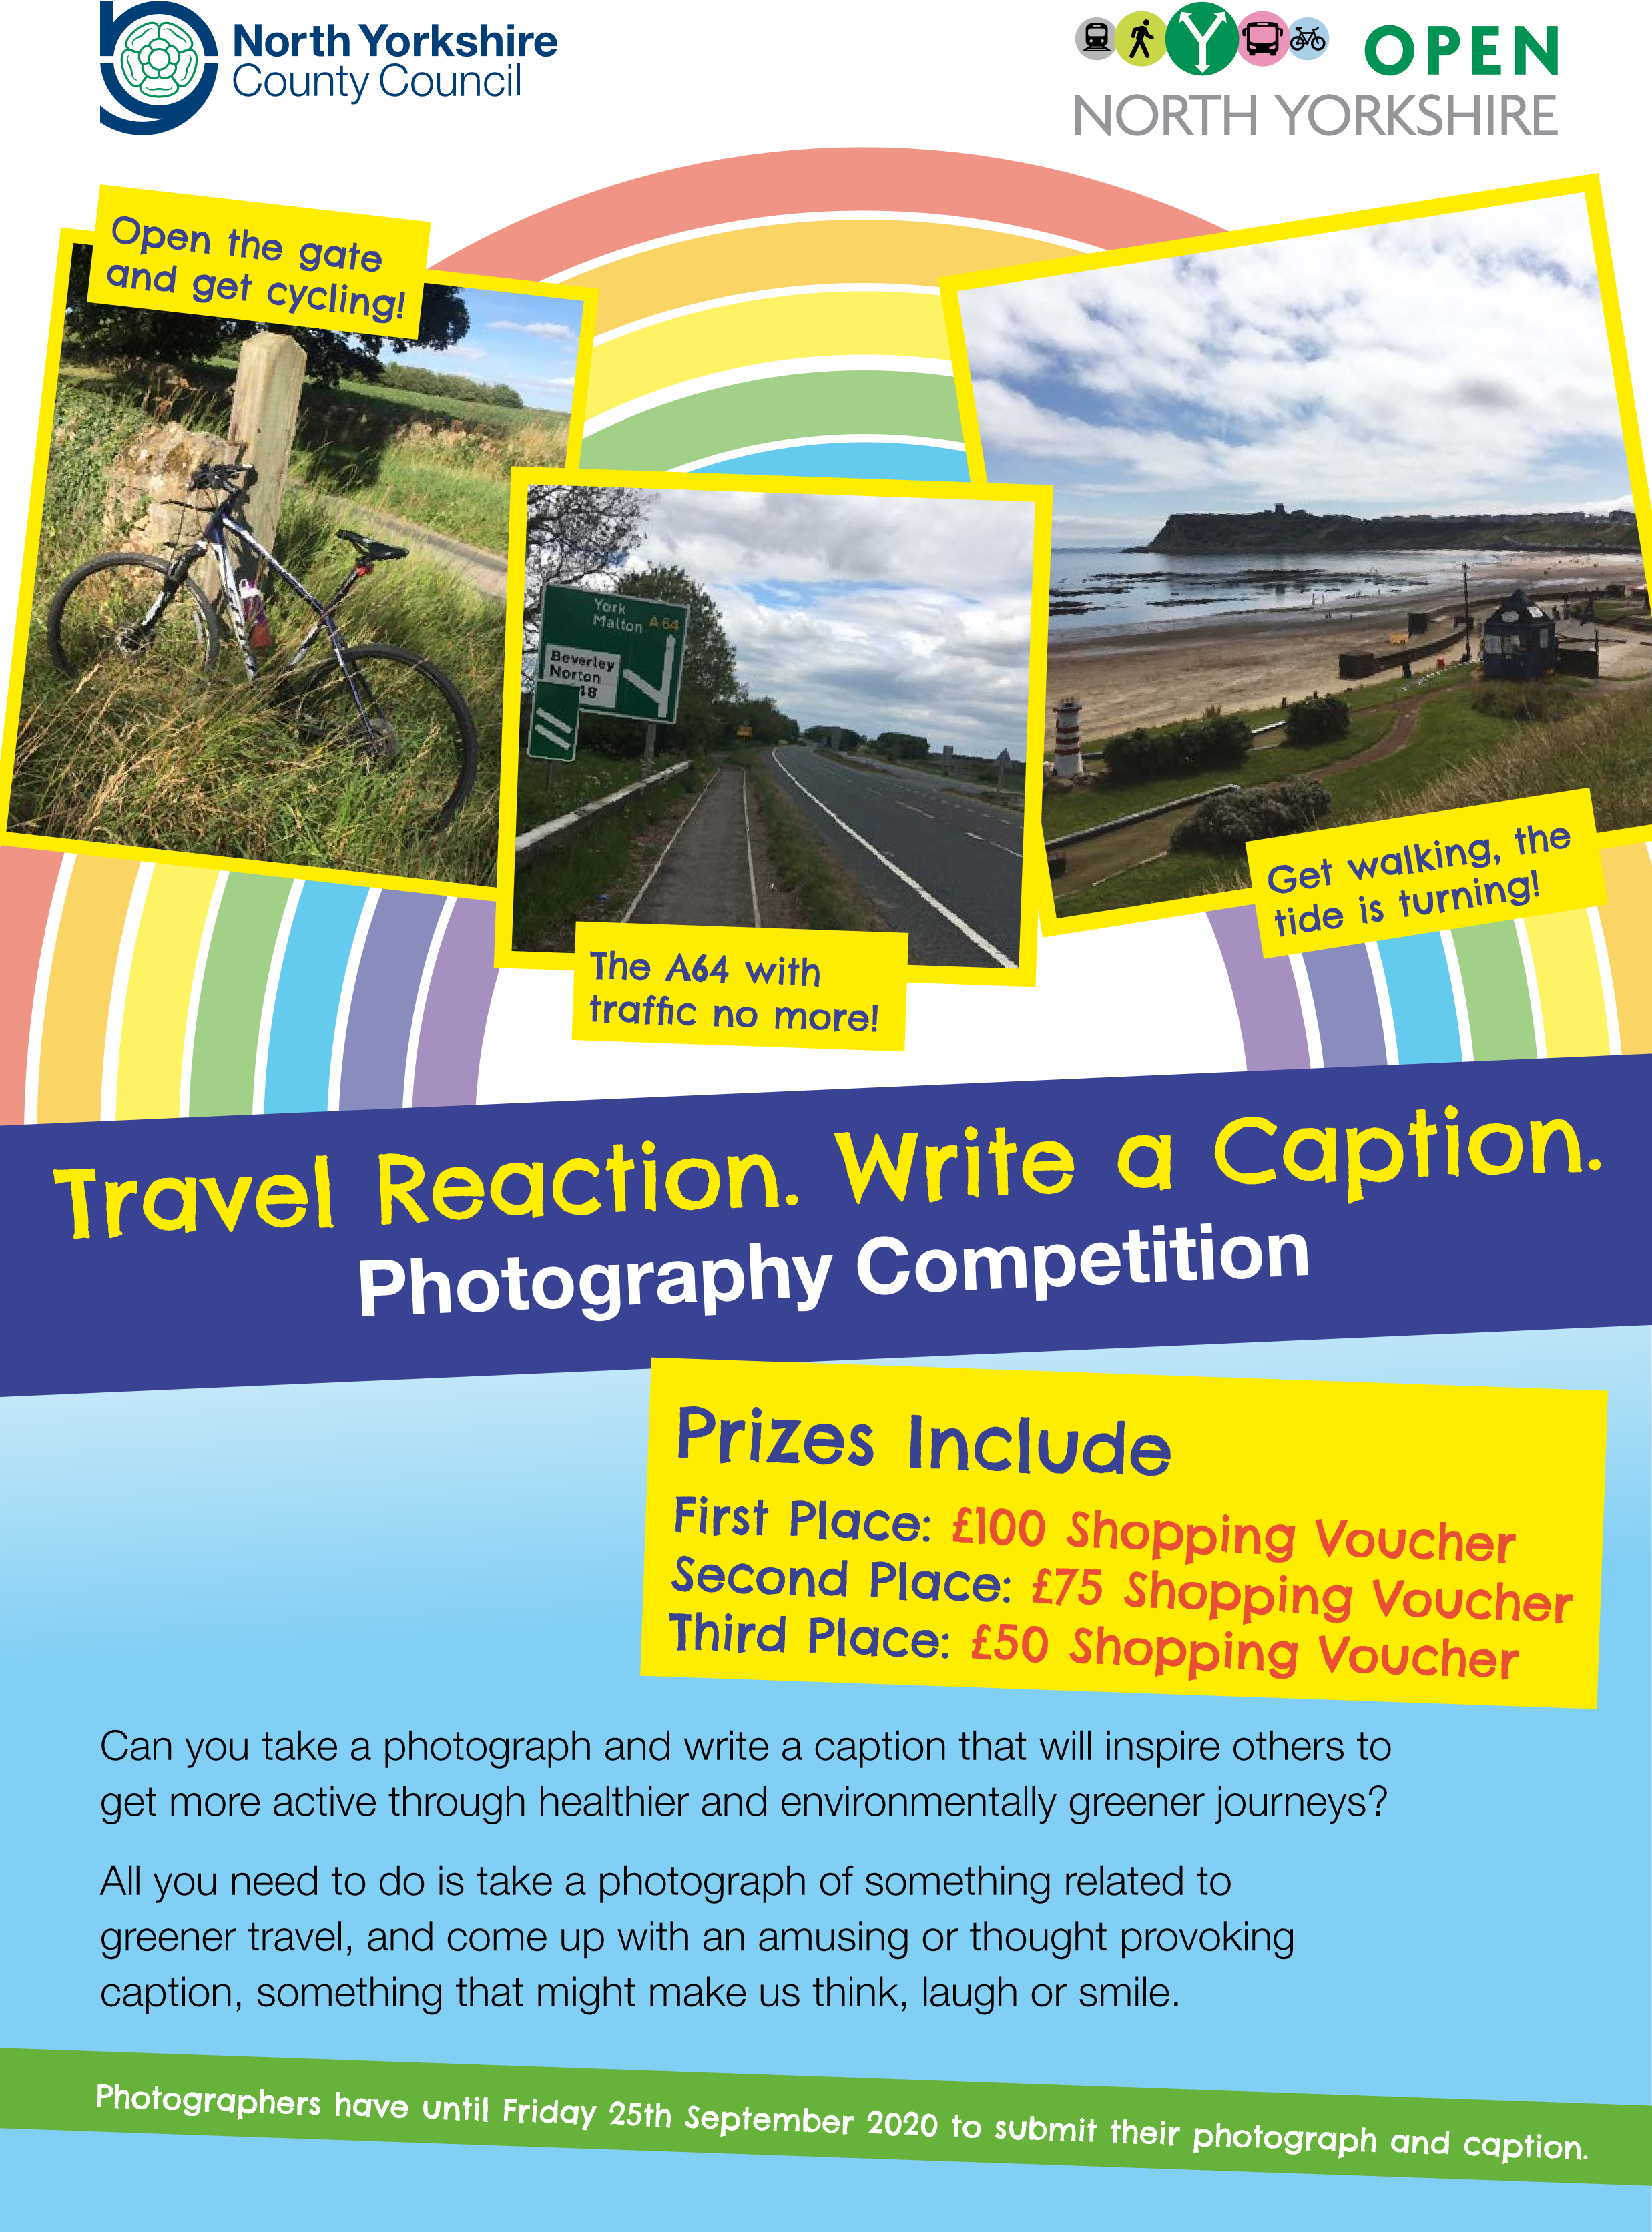

# Prizes and Judging

We will select one winner and two runners up.

All winning entries will be framed and showcased in a special Sustainable Art exhibition at County Hall, Northallerton.

Artwork will be judged by a panel made up of representatives from North Yorkshire County Council.

# Judging Criteria

Originality

Creative ideas

Thought provoking or humorous caption

Does it fit the brief?

Photographers have until Friday 25th September 2020 to submit their photograph and caption.

# Guidelines/Rules

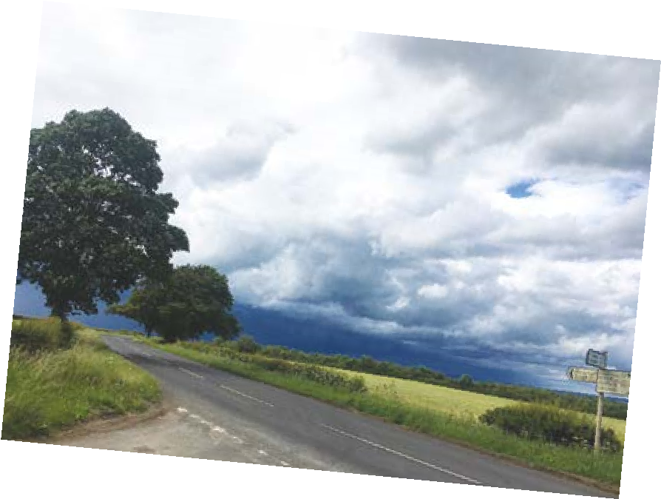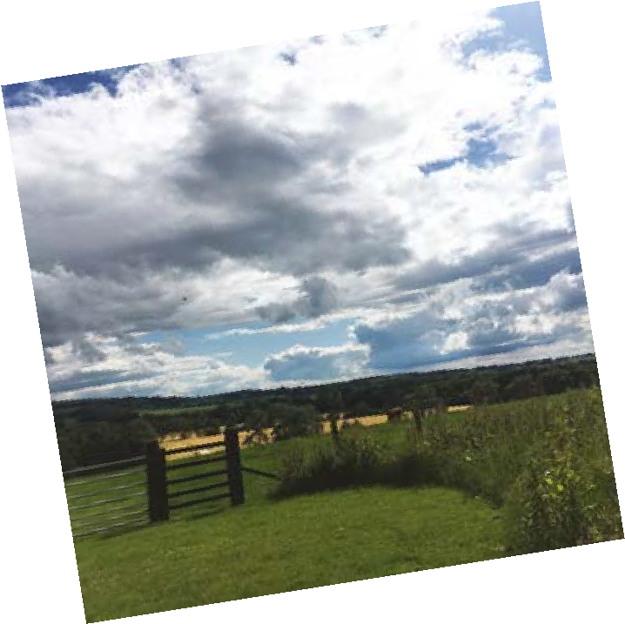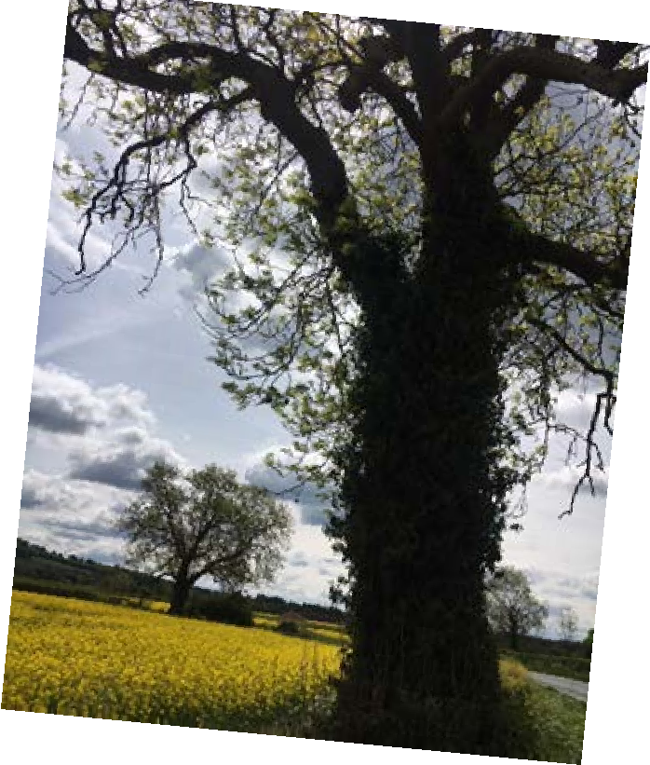

The sky’s the limit – in it to win it

* All you need to do is email your photograph to the email address below, providing us with your full name, address, phone number, as well as the all-important caption (just include it in the email, you don’t need to Photoshop it onto your photo).
* Photographs should be submitted as a high resolution file, preferably JPEG or PDF (under 10Mb).
* Your photograph must be taken by you.
* Please submit your photograph and caption by Friday 25th September 2020 by emailing it to caption.opennorthyorkshire@northyorks.gov.uk
* By entering, you consent to allow us to use your photograph and caption on social media and in other publicity.

82230 07/20